A000-Afr-Gabon-Kota peoples-Mahongue Group-Reliquary Ensemble-late 19th c

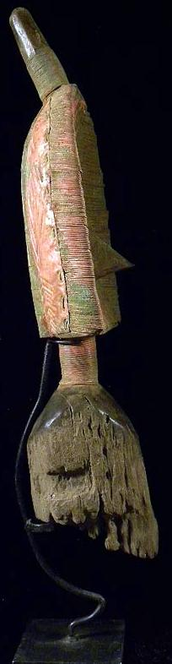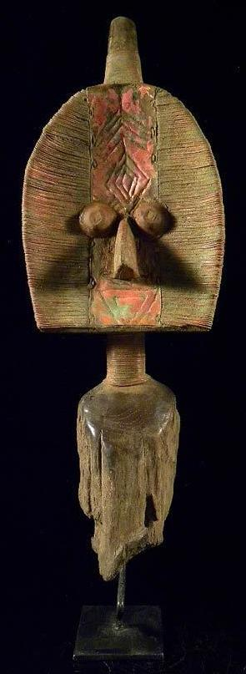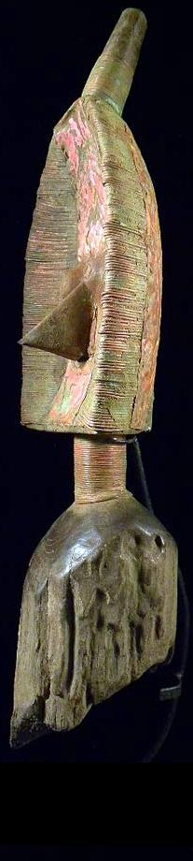

Case No.: 6

**Accession No.**

**Formal Label:** Afr-Gabon-Kota peoples-Mahongue Group-Reliquary Ensemble-late 19th c

**Display Description:**

This type of a sculptural element from a Kota reliquary ensemble was the first example to be recognized in Europe as a major tradition of reliquary sculpture developed in eastern Gabon. A similar specimen dating to 1876 was collected by Oskar Lenz a geologist of the Deutsche Gesellschaft zur Erforschung Aqua­torialafrikas. His specimen (which he referred to it as a "fetish-idol" of the "Aduma" and "Oschebo" peoples of the Middle Ogooue River) has been in the Museum für Volkerkunde in Berlin since 1875 (Siroto 1968: 24).We now know that specimens were created by peoples located between the eastern tributaries of the Lower Ivindo River: the Shake, BoNgom, and Ndambomo groups (Kele-speaking peo­ples) and the Mahongwe, BuSamai, and Kota groups (Kota-speaking peoples) (Siroto 1968:89).

This specimen was part of an ancestral devotional cult of the Kota, Mahongwe, and Shamaye and was conserved by clan members (Perrois 1969: 9). The highly abstract Mahongwe representations are distinctive for their construction, which encases a wood core within a brass sheath. These are often described as "foliate," given their flattened leaf-like configuration. The three-dimensional design is subtly modulated by concavity of the face constructed on the carved-wood understructure, and by the shifting surface textures of the applied metal wires and sheets. The shape of the head is ovoid, with a straight lower edge. The head is surmounted by a cylindrical extension encased in brass wire that is positioned at a ca. forty-five-degree angle, a feature that represents a thick braid, called the *i-benda*, which is worn by notables in a traditional hairstyle known as *bakani* (Perrois and Siroto 1969: 67)

A broad median band extends from the upper rim to the horizontal base of the face. A cluster of four chevrons and four concentric lozenges decorate its upper part. Two applied circular metal eyes have a staring aspect associated with spiritual or hallucinatory experience and are separated by the bridge of the beak-like nose, made from a projecting brass element. (Siroto 1968: 87, fig. 8). Below the nose are two concentrric inverted triangles as a mouth element. On either side of the central axis, the surface is covered with carefully applied cut-metal bands that create a succession of horizontal striations. The cylindrical neck which is wrapped in brass wire mirrors the form of the coiffure. Below the neck the wood has deteriorated from having been placed within an ancestral relic basket.

This specimen is among the finest of its kind for its breadth of dimensions and artistry of construction. The width of the head is ___ cm. and its height is ___ cm. rendering the aspect of a broad mask. The filaments that extend horizontally across its surface are oval affording a contrastive concave surface area. The virtuosity of the metalwork is apparent both on the front, where the folded fila­ment tips form a delicate seam along either side of the ver­tical axis and the back where these filaments seamlessly blend with the metal sheathing an its multiple chevron and concentric lozenge elements and the back ten-part median band extending from the chignon.

**LC Classification:**

**Date or Time Horizon:**

**Geographical Area:**

**Map:**

**GPS coordinates:**

**Cultural Affiliation:**

**Media:** Wood, copper, brass, natural fiber

**Dimensions: H** 22.4 in.

**Weight:**

**Condition:**

**Provenance:**

**Discussion:**

**References:**

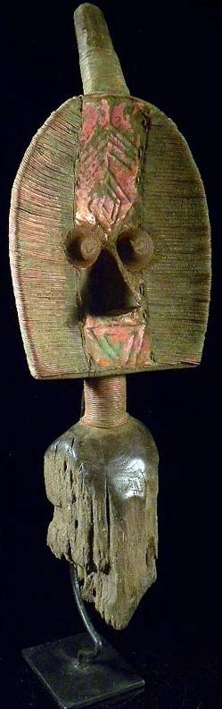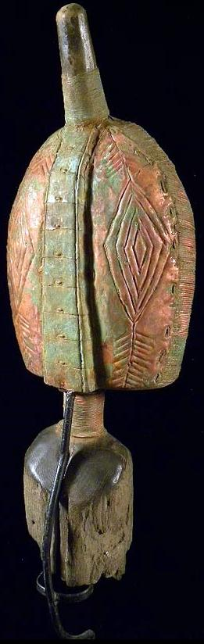

The sculpture displays a complex hair style on the reverse, where the filaments have been wrapped around the edges so that their ends define an alternating serrated border around the outer perimeter. At the center, aligned with and below the extension of the chignon, is a median axis composed of two parallel raised ridges that span the entire length of the back. On either side are bilat­erally symmetrical repoussé designs of a series of concen­tric triangles that reach to the outer edges. These densely stippled graphic patterns afford the work another textural dimension. Directly below the striated coiled neck, the plated surfaces of the base are embossed with a network of lozenges.

In Mahongwe society such works were assigned guardianship of relics derived from singularly important individuals. According to Louis Perrois, the candidates worthy of contributing relics included not only a clan's most distinguished male leaders but also mothers of an exceptional number of children or of twins, the latter being associated with prosperity and good fortune (Perrois 1969: 11). Leon Siroto notes that those who distinguished themselves were perceived to be invested with mystical powers that inhered in their skulls following their death. Close relatives in turn retained these as a means of positively influencing the affairs of their extended family (Siroto 1968, :22-23). The foliate figure that surmounts the relic was intended to deflect any adversaries from interfering with its power (Siroto 1968,: 86).

Such works were also taken out of seclusion by clan leaders and deployed in village rites in response to signifi­cant crises such as the death of a communal leader, the approach of an epidemic, or the launch of a dangerous hunting expedition. In order to intensify their potential to address these concerns effectively and fortify the commu­nity on such occasions, all the reliquaries of a village were brought together in the belief that their combined power constituted a formidable protective barrier and an impene­trable shield (Siroto 1968: 27).

References:

Perrois, Louis. 1969. *Le Bwété des Kota Mahongwe du Gabon: note sur figures fueneraires des populations du bassin d'Ivindo*. Libreville: OSTROM.

Perrois, Louis. 1969. Notes on the Bwuiti figures: response to Leon Siroto's article, 'The face of the Bwiti.'

Siroto, Leon. 1969. Author's reply, *African Arts* 2 (no. 4),: 65-69.:

Siroto, Leon. 1969. Masks and social organization among the Bakwele people of western equatorial Africa. Ph.D. diss. New York: Columbia University.

This superb creation is considered the finest of its kind for its physical breadth and the artistry of its construction. When the work is compared with the previous example, collected by Oskar Lenz (cat. no. 51), a series of striking and subtle distinctions are apparent. Not only is the width of the head greater in expanse, but the filaments that extend horizontally across the surface are not as flattened, affording the work greater surface contrast. Another distinc­tion lies in the manner in which the tips of those filaments are integrated into the decorative scheme of both the front and back sides, to very different ends. The virtuosity of the metalwork is apparent on the front, where the folded fila­ment tips form a delicate seam along either side of the ver­tical axis in a manner reminiscent of fine needlepoint.

No mere two-dimensional frontal representation, the sculpture displays even more complex adornment on the reverse. Here the filaments have been wrapped around the edges so that their ends define an elegant alternating serrated border around the outer perimeter. At the center, aligned with and below the extension of the chignon, is a median axis composed of four parallel raised ridges that span the entire length of the back. On either side are bilat­erally symmetrical repousse designs of a series of concen­tric triangles that reach to the outer edges. These densely stippled graphic patterns afford the work another textural dimension. Directly below the striated coiled neck, the plated surfaces of the base are embossed with a network of lozenges.

In Mahongwe society such works were assigned guardianship of relics derived from singularly important individuals. According to Louis Perrois, the candidates worthy of contributing relics included not only a clan's most distinguished male leaders but also mothers of an exceptional number of children or of twins, the latter being associated with prosperity and good fortune) Leon Siroto notes that those who distinguished themselves were perceived to be invested with mystical powers that inhered in their skulls following their death. Close relatives in turn retained these as a means of positively influencing the affairs of their extended family.2 The foliate figure that sur­ mounts the relic was intended to deflect any adversaries from interfering with its power.3

Such works were also taken out of seclusion by clan leaders and deployed in village rites in response to signifi­cant crises such as the death of a communal leader, the approach of an epidemic, or the launch of a dangerous hunting expedition. In order to intensify their potential to address these concerns effectively and fortify the commu­nity on such occasions, all the reliquaries of a village were brought together in the belief that their combined power constituted ,a formidable protective barrier and an impene­trable shield.4

|  |  |  |  |  |
| --- | --- | --- | --- | --- |
| |  |  |  | | --- | --- | --- | | [Back to My eBay](javascript:history.go(-1)) | | | Listed in category:   * [Antiques](http://www.ebay.com/sch/Antiques-/20081/i.html) > [Ethnographic](http://www.ebay.com/sch/Ethnographic-/2207/i.html) > [African](http://www.ebay.com/sch/African-/37945/i.html) > [Sculptures & Statues](http://www.ebay.com/sch/Sculptures-Statues-/37947/i.html) | |  |

You won this auction. | [View order details](http://payments.ebay.com/ws/eBayISAPI.dll?ViewPaymentStatus&transid=0&itemId=230860738544)

|  |  |  |
| --- | --- | --- |
| **\*\* Fine Tribal Guard Statue MAHONGUE / Gabon \*\***  [See original listing](http://www.ebay.com/itm/Fine-Tribal-Guard-Statue-MAHONGUE-Gabon-/230860738544?_trksid=p2047675.l2557&ssPageName=STRK:MEWNX:IT&nma=true&si=sA0CK1qSnGO2mwdjPpn99JUiuz4%3D&orig_cvip=true&rt=nc) | | |
| |  |  | | --- | --- | | |  | | --- | |  | | |  |  |
|  |  |
| Item condition:  -- |  |
| Ended:  Oct 14, 2012 13:07:14 PDT |  |
| Winning bid:  US $590.00  [ [31 bids](http://offer.ebay.com/ws/eBayISAPI.dll?ViewBids&_trksid=p2047675.l2565&rt=nc&item=230860738544) ] |  |
| Shipping:  $38.00 Standard Shipping |  |
| Item location:  Vienna, Austria |  |
| Seller:  [art-afrique](http://myworld.ebay.com/art-afrique?_trksid=p2047675.l2559) ([8149](http://feedback.ebay.com/ws/eBayISAPI.dll?ViewFeedback&userid=art-afrique&iid=230860738544&ssPageName=VIP:feedback&ftab=FeedbackAsSeller&rt=nc&_trksid=p2047675.l2560)  |  [Seller's other items](http://www.ebay.com/sch/art-afrique/m.html?item=230860738544&ssPageName=STRK%3AMEWNX%3AIT&rt=nc&_trksid=p2047675.l2562) |  |

* [Sell one like this](http://cgi5.ebay.com/ws/eBayISAPI.dll?SellLikeItem&_trksid=p2047675.l2792&rt=nc&item=230860738544)